**WT MID-2 ANSWERS**

**MODULE-3**

**1.** **Develop a program to demonstrate the use of cookies in servlets with an**

**example.**

**Ans:**

index.html

1. <form action="servlet1" method="post">
2. Name:<input type="text" name="userName"/><br/>
3. <input type="submit" value="go"/>
4. </form>

### FirstServlet.java

1. **import** java.io.*;
2. **import** javax.servlet.*;
3. **import** javax.servlet.http.*;

6. **public** **class** FirstServlet **extends** HttpServlet {
8. **public** **void** doPost(HttpServletRequest request, HttpServletResponse response){
9. **try**{
11. response.setContentType("text/html");
12. PrintWriter out = response.getWriter();
14. String n=request.getParameter("userName");
15. out.print("Welcome "+n);
17. Cookie ck=**new** Cookie("uname",n);//creating cookie object
18. response.addCookie(ck);//adding cookie in the response
20. //creating submit button
21. out.print("<form action='servlet2'>");
22. out.print("<input type='submit' value='go'>");
23. out.print("</form>");
25. out.close();
27. }**catch**(Exception e){System.out.println(e);}
28. }
29. }

### SecondServlet.java

1. **import** java.io.*;
2. **import** javax.servlet.*;
3. **import** javax.servlet.http.*;
5. **public** **class** SecondServlet **extends** HttpServlet {
7. **public** **void** doPost(HttpServletRequest request, HttpServletResponse response){
8. **try**{
10. response.setContentType("text/html");
11. PrintWriter out = response.getWriter();
13. Cookie ck[]=request.getCookies();
14. out.print("Hello "+ck[0].getValue());
16. out.close();
18. }**catch**(Exception e){System.out.println(e);}
19. }
20. }

**Output:**

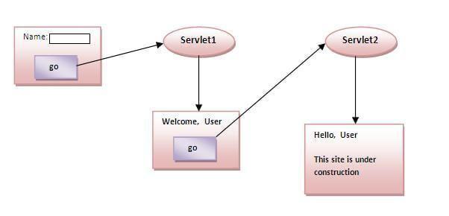

**2.** **Describe how HTTP sessions are used in Session tracking with an**

**example**

**Ans:**

**Session** simply means a particular interval of time.

**Session Tracking** is a way to maintain state (data) of an user. It is also known as **session management** in servlet.

Http protocol is stateless so we need to maintain state using session tracking techniques. Each time a user requests to the server, the server treats the request as the new request. So we need to maintain the state of a user to recognize a particular user.

HTTP is stateless, which means each request is considered as the new request. It is shown in the figure given below:

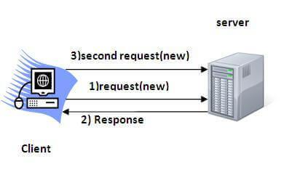

Session Tracking Techniques

There are four techniques used in Session tracking:

1. **Cookies**
2. **Hidden Form Field**
3. **URL Rewriting**
4. **HttpSession**

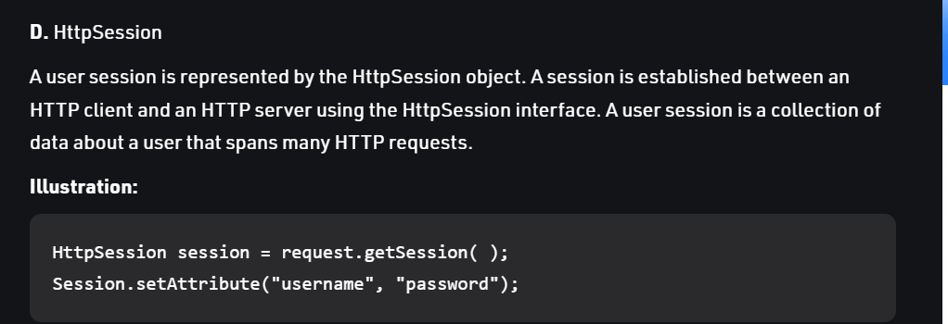

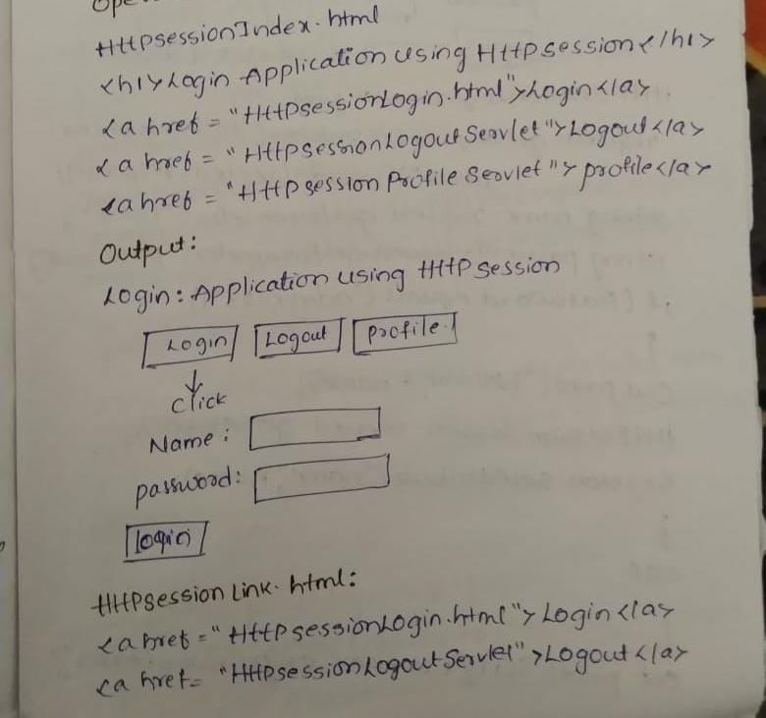

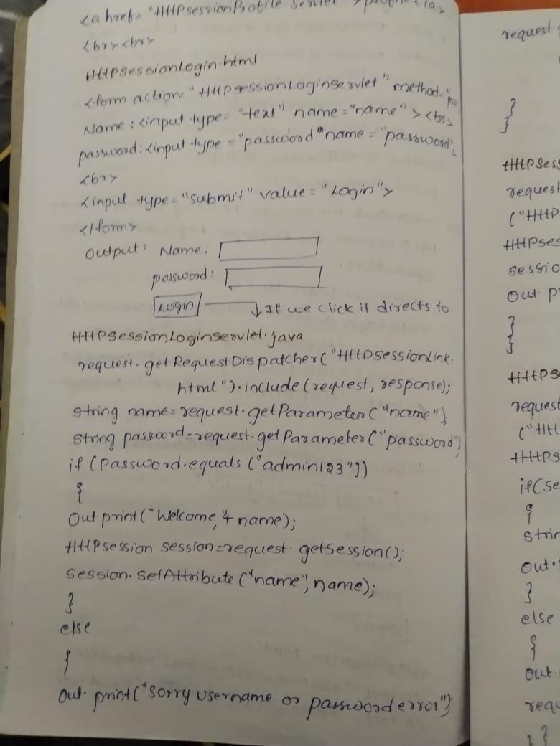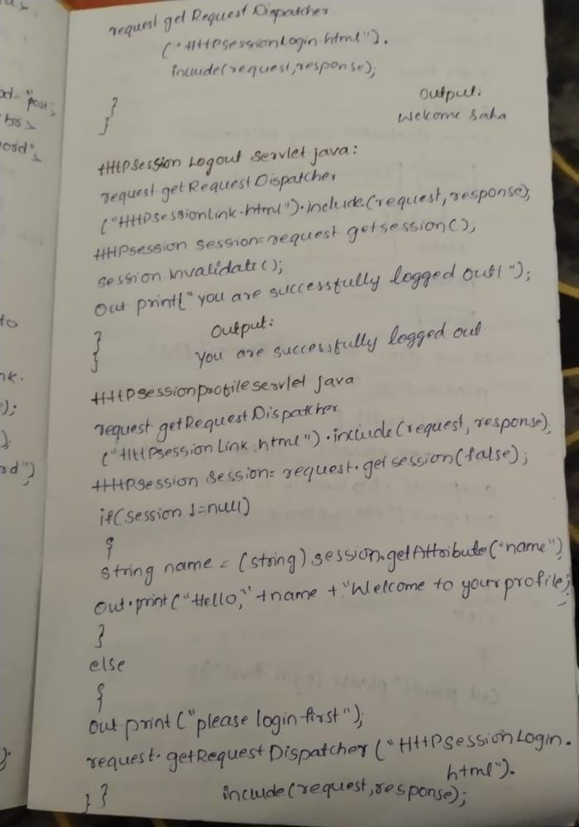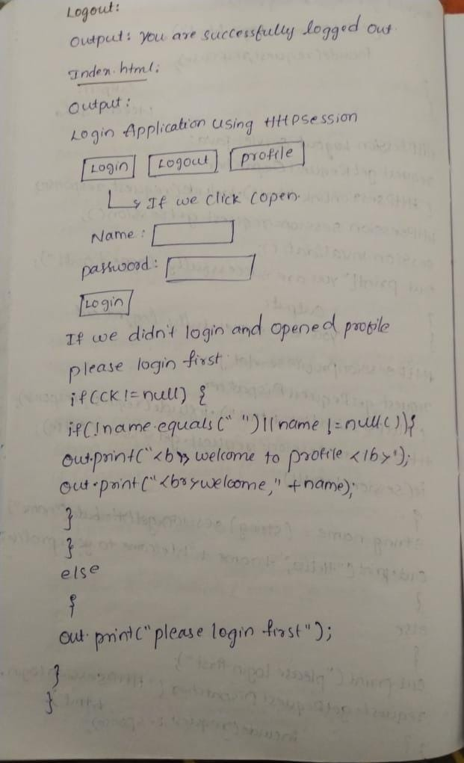

**3.** **Develop a servlet program to retrieve data from the database.**

**Ans:**

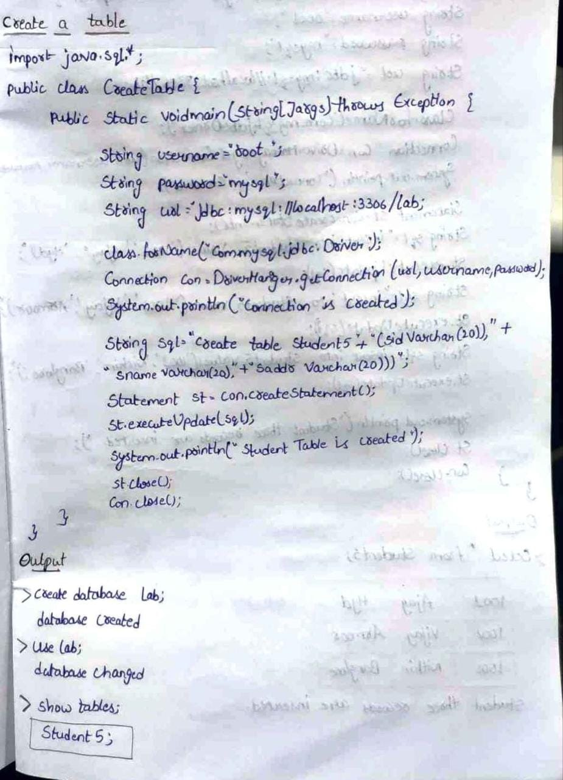

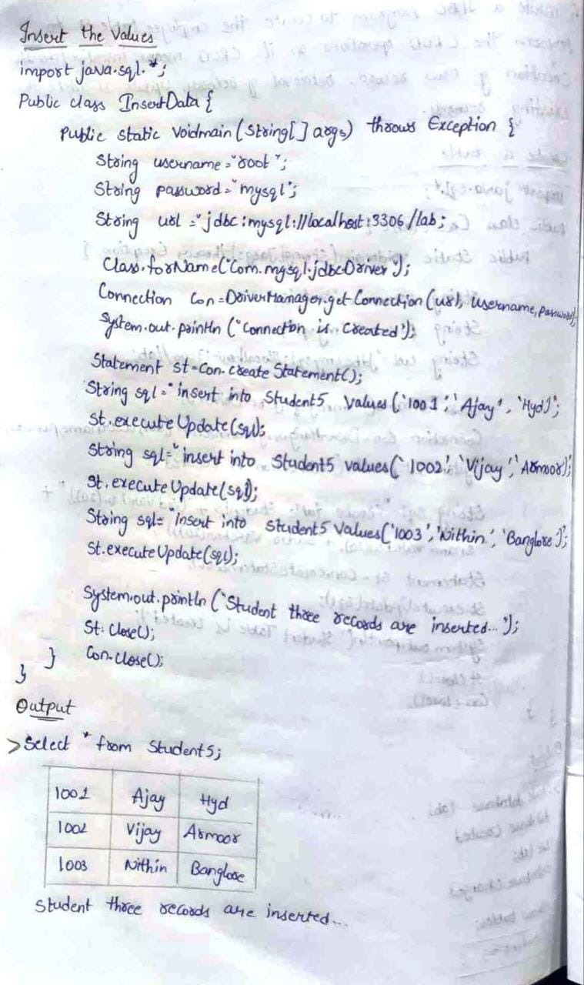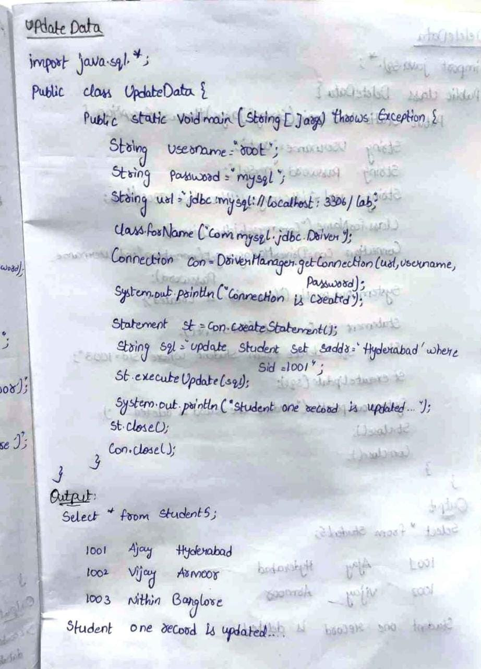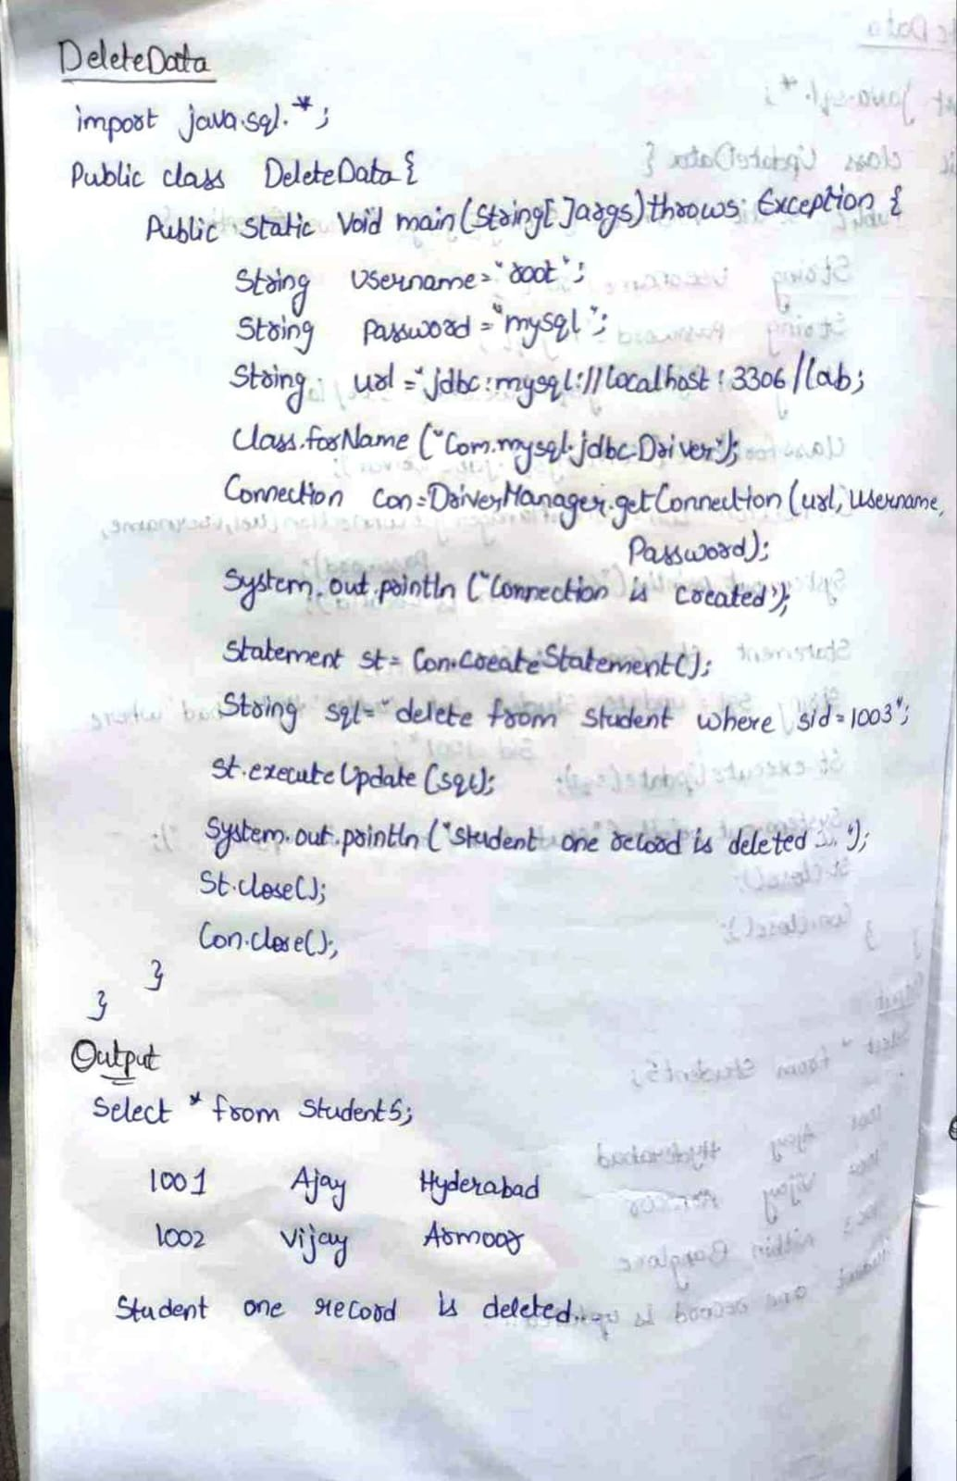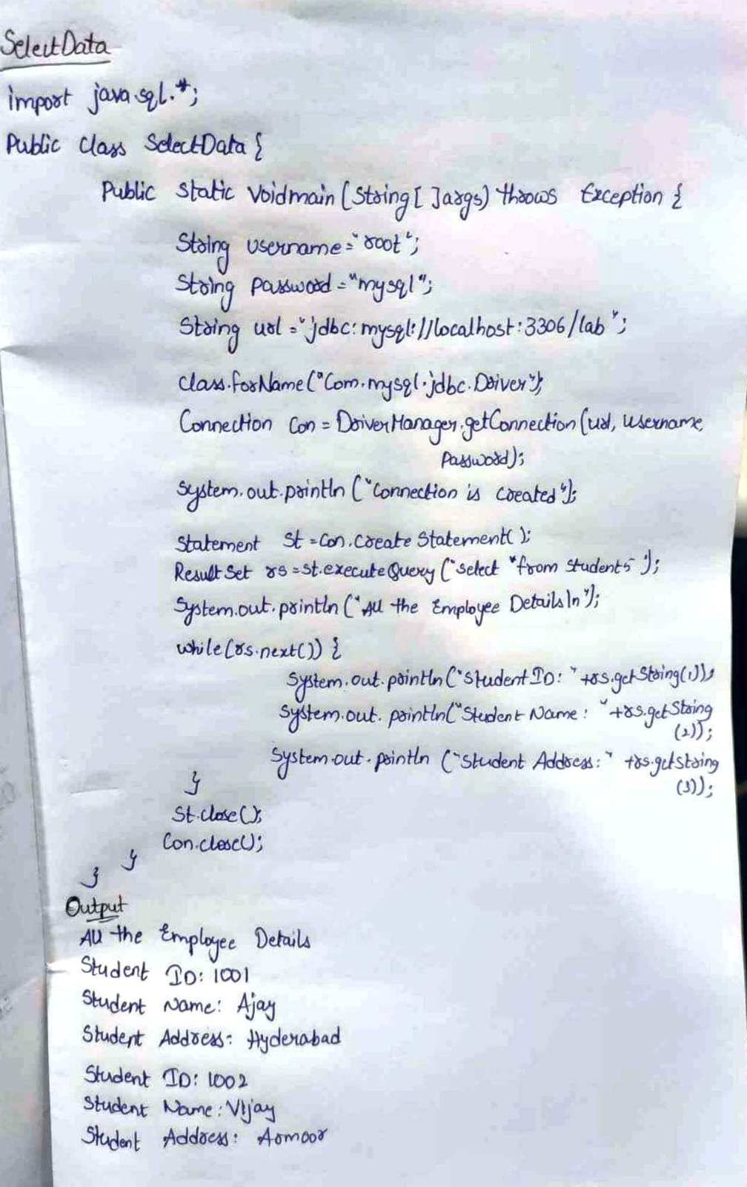

**4.Write short notes on a) Statement Interface b) ResultSet Interface**

**Ans:**

# **Statement interface**

The **Statement interface** provides methods to execute queries with the database. The statement interface is a factory of ResultSet i.e. it provides factory method to get the object of ResultSet.

### Commonly used methods of Statement interface:

The important methods of Statement interface are as follows:

| **1) public ResultSet executeQuery(String sql):**  is used to execute SELECT query. It returns the object of ResultSet. |
| --- |
| **2) public int executeUpdate(String sql):** is used to execute specified query,  it may be create, drop, insert, update etc. |
| **3) public boolean execute(String sql):** is used to execute queries that may return multiple results. |
| **4) public int[] executeBatch():** is used to execute batch of commands. |

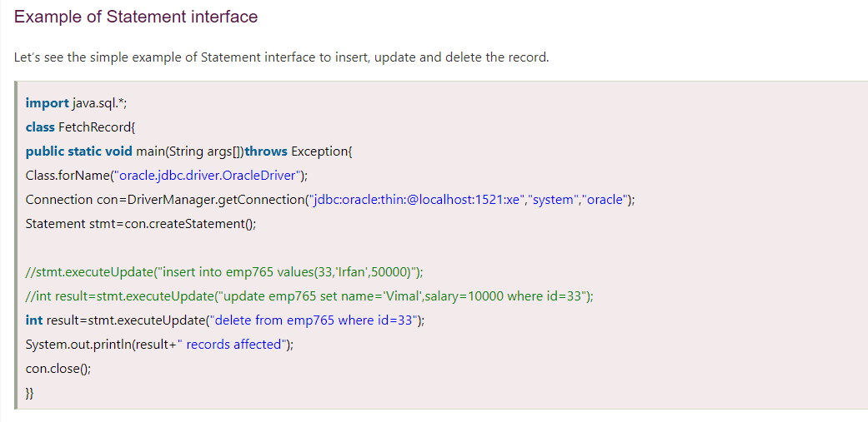

# **ResultSet interface**

The object of ResultSet maintains a cursor pointing to a row of a table. Initially, cursor points to before the first row.

#### **By default, ResultSet object can be moved forward only and it is not updatable.**

But we can make this object to move forward and backward direction by passing either TYPE_SCROLL_INSENSITIVE or TYPE_SCROLL_SENSITIVE in createStatement(int,int) method as well as we can make this object as updatable by:

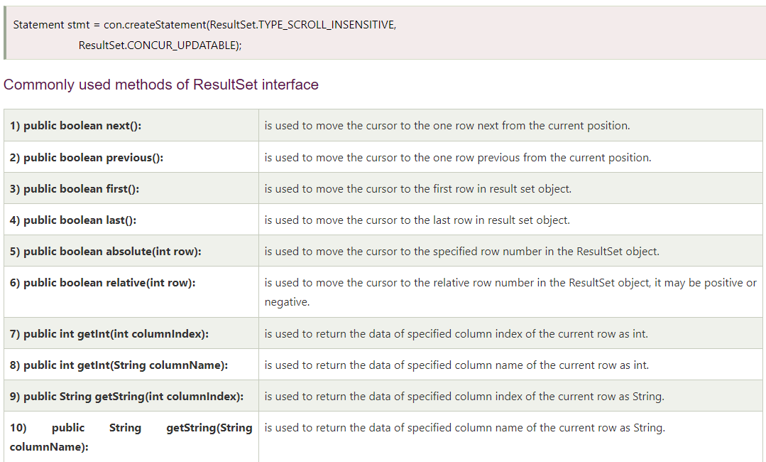

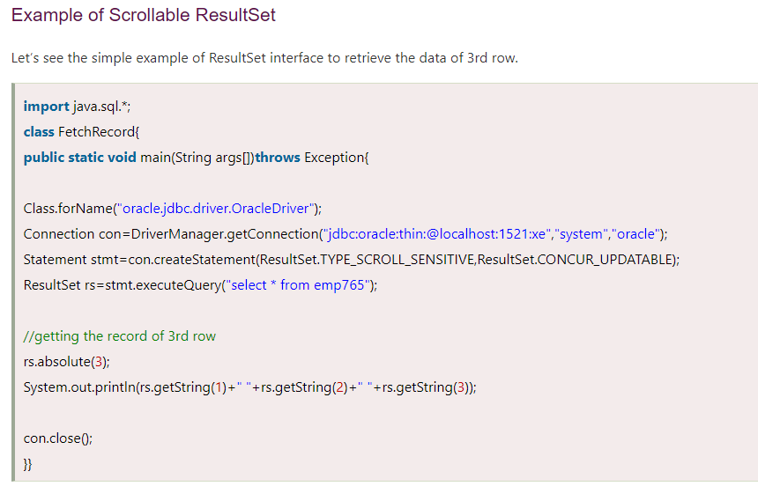

**Module-4**

1. **Summarize the features of JSP tag extensions and libraries.**

**Ans:**

Tag extensions or custom tags are application-defined language extensions to Java Server Pages. Some custom-tag activities relate to the tag library, whereas others relate to individual tags within the library.

The scripting elements provides the ability to insert java code inside the jsp. There are three types of scripting elements:

* scriptlet tag
* expression tag
* declaration tag

**1.scriplet tag**

A scriptlet tag is used to execute java source code in JSP. Syntax is as follows:

1. <%  java source code %>

Example of JSP scriptlet tag

In this example, we are displaying a welcome message

1. **<html>**
2. **<body>**
3. **<**% out.print("welcome to jsp"); %**>**
4. **</body>**
5. **</html>**

**Output:** welcome to jsp

**2.expression tag**

The code placed within **JSP expression tag** is *written to the output stream of the response*. So you need not write out.print() to write data. It is mainly used to print the values of variable or method.

### Syntax of JSP expression tag

1. **<**%=  statement %**>**

### Example of JSP expression tag

In this example of jsp expression tag, we are simply displaying a welcome message.

1. **<html>**
2. **<body>**
3. **<**%= "welcome to jsp" %**>**
4. **</body>**
5. **</html>**

#### **Note: Do not end your statement with semicolon in case of expression tag.**

**Output:** welcome to jsp

**3.declaration tag**

The **JSP declaration tag** is used *to declare fields and methods*.

The syntax of the declaration tag is as follows:

1. **<**%!  field or method declaration %**>**

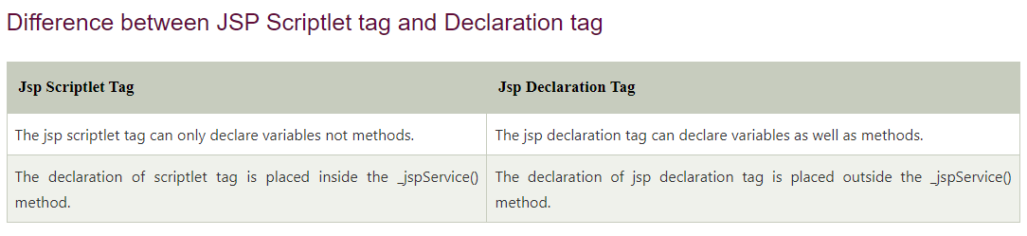**Example**

1. **<**%! int data=50; %**>**
2. **<**%= "Value of the variable is:"+data %**>**
3. **<**%!
4. int cube(int n){
5. return n*n*n*;
6. }
7. %**>**
8. **<**%= "Cube of 3 is:"+cube(3) %**>**

**Output:**

Value of the variable is: 50

Cube of 3 is: 27

1. **Explain anatomy of a JSP page.**

**Ans:**

A JSP page is a normal web page with JSP elements for generating the parts of the web page that differ for each request. A simple JSP web page that contains the JSP elements and template text. Everything on the page that is not a JSP element is called Template text. Template text can be any text, i.e., HTML, XML, WML or even plain text.JSP has no dependency on HTML, it can be used with any markup language. Template text is always passed straight to the browser.

**JSP Elements**

There are three types of JSP elements present:

* Directive
* Action
* Scripting

**1. Directive Elements**

page: <%@ page … %>

* Defines page-dependent attributes, such as session tracking, error page, and buffering requirements.
* is used for importing a package.
* is used for Handling an Exception.

Attributes that we can use are:

* language=”Scripting language” : is used to set which type of language it is.
* import=”import List” : is used to import the packages,and so on…
* session=”true/false”
* contentType=”ctinfo”
* errorPage=”error-url”
* isErrorPage=”true/false”
* info=”information”
* isELIgnored=”true/false”
* isThreadSafe=”true/false”

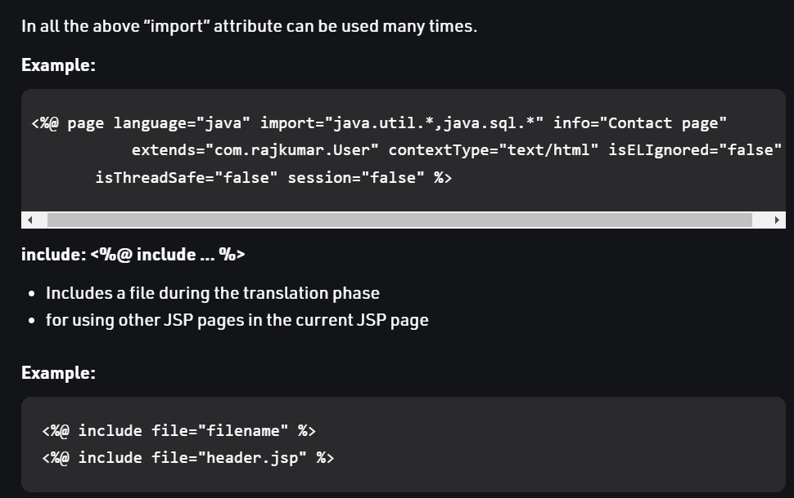

**2. Action Tag/Element**

* JSP Action tags or Elements are used to perform some specific tasks. The action tags are used to control the flow between pages and to use Java Beans. There are many JSP action tags.
* jsp:forward: forwards the request and response to another resource.
* jsp:include: includes another resource.
* jsp:useBean: creates or locates bean object.
* jsp:setProperty: sets the value of property in bean object.
* jsp:getProperty: prints the value of the property of the bean.
* jsp:plugin: embeds another component such as applet.
* jsp:param: sets the parameter value. It is used in forward and includes mostly.
* jsp:fallback: can be used to print the message if the plugin is working. It is used in jsp:plugin.

**3. Scripting Element**

Scriptlet elements must be written within the <% … %> tags.The Scriptlet tag allows writting Java code statements within the JSP page.The tag is responsible for implementing the functionality of “_jspService()” by scripting the java code.The JSP engine will process any code written within the pair of <% and %> tags and any other code is treated as plain text while translating the JSP page. There are three main subdivisions of Scripting Elements in Java Server Pages.

* Expression Tag
* Scriptlet Tag
* Declaration Tag

(Can refer from 1st answer)

1. **Explain how a Servlet communicate with a JSP page?**

**Ans:**

**The servlet communicate with a JSP page by**

getServletConfig().getServletContext().getRequestDispatcher(“jspfilepathtoforward”).forward(request, response);

When a servlet jsp communication is happening, it is not just about forwarding the request to a JSP from a servlet. There might be a need to transfer a string value or on object itself.

Following is a servlet and JSP source code example to perform Servlet JSP communication. Wherein an object will be communicated to a JSP from a Servlet.

## Following are the steps in Servlet JSP Communication:

1. Servlet instantiates a bean and initializes it.  
2. The bean is then placed into the request  
3. The call is then forwarded to the JSP page, using request dispatcher.

Example Servlet Source Code: (ServletToJSP.java)

public class ServletToJSP extends HttpServlet {

public void doGet(HttpServletRequest request, HttpServletResponse response) throws ServletException, IOException {

//communicating a simple String message.

String message = "Example source code of Servlet to JSP communication.";

request.setAttribute("message", message);

//communicating a Vector object

Vector vecObj = new Vector();

vecObj.add("Servlet to JSP communicating an object");

request.setAttribute("vecBean",vecObj);

//Servlet JSP communication

RequestDispatcher reqDispatcher = getServletConfig().getServletContext().getRequestDispatcher("/jsp/javaPapers.jsp");

reqDispatcher.forward(request,response);

}

}

Example JSP Source Code: (javaPapers.jsp)

<html>

<body>

<%

String message = (String) request.getAttribute("message");

out.println("Servlet communicated message to JSP: "+ message);

Vector vecObj = (Vector) request.getAttribute("vecBean");

out.println("Servlet to JSP communication of an object: "+vecObj.get(0));

%>

</body>

</html>

1. **Write the JSP advantages and disadvantages over servlets**

**Ans:**

**JSP Versus SERVLETS**  
It is been seen that JSP and Servlets provides dynamic content to a web-page, but in a different way. Both technologies are powerful and complimentary to each other. Servlets and JSP operate quite differently and even opposite at some extent. A Servlet is a simple Java program in which html is embedded. The Java program executes on the server-side and display the result to the browser by embedding html which is output to the browser. The Servlet embed html into Java code through out.println statements.

**Advantages of JSP over Servlets**

1. Servlets use println statements for printing an HTML document which is usually very difficult to use. JSP has no such tedius task to maintain.
2. JSP needs no compilation, CLASSPATH setting and packaging.
3. In a JSP page visual  content and logic are seperated, which is not possible in a servlet.
4. There is automatic deployment of a JSP, recompilation is done automatically when changes are made to JSP pages.
5. Usually with JSP, Java Beans and custom tags web application is simplified.

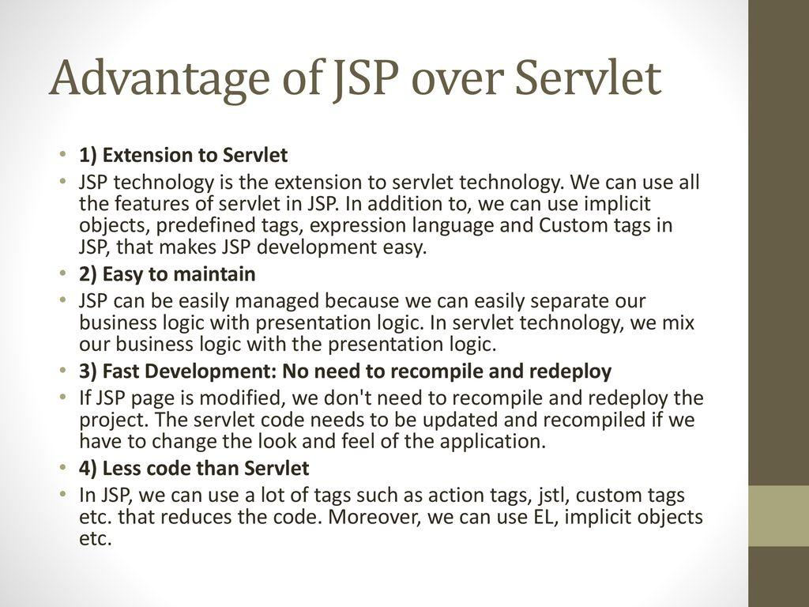

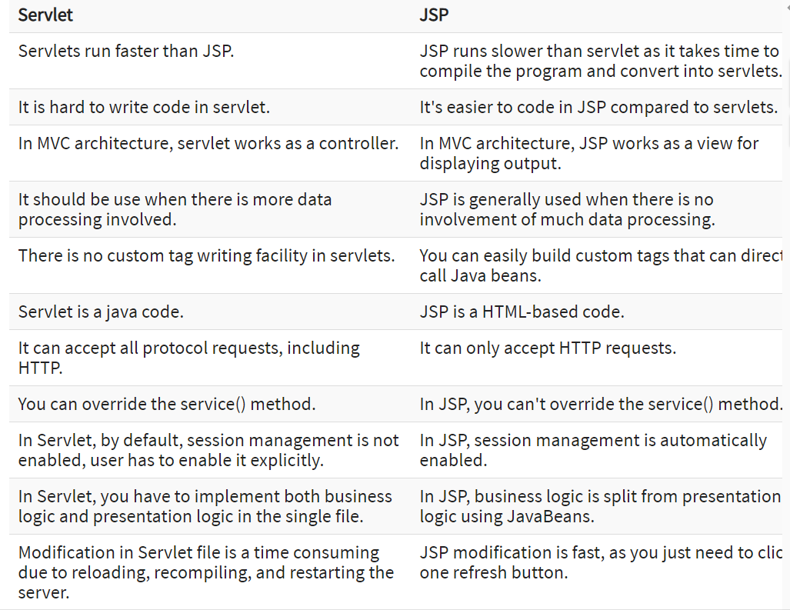

**5.Develop a JSP program to display current date and time.**

**Ans:**

**JSP** technology is used to create web application just like Servlet technology. It can be thought of as an extension to Servlet because it provides more functionality than servlet such as expression language, JSTL, etc.

A JSP page consists of HTML tags and JSP tags. The JSP pages are easier to maintain than Servlet because we can separate designing and development. It provides some additional features such as Expression Language, Custom Tags, etc.

With JSP program, it is very easy to get the current date and the time. You can use a simple Date object with the ***toString()*** method to print the current date and the time.

**Code:**

**<html> <head><title>JSPApp</title></head>**

**<body>**

**<form>**

**<legend><b><i>JSP Application<i><b></legend>**

**<h3>Current Date and Time is :</h3>**

**<% java.util.Date d = new java.util.Date();**

**out.println(d.toString()); %>**

**</form>**

**</body>**

**</html>**

**Output:**

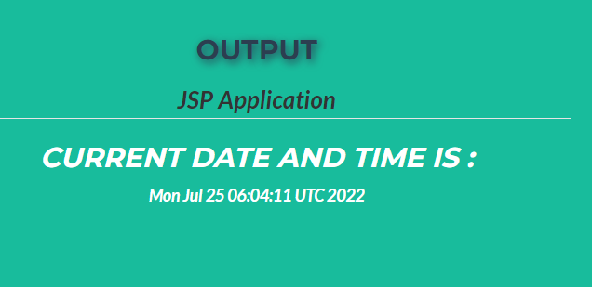

1. **Elaborate the features of JSP processing**

**Ans:**

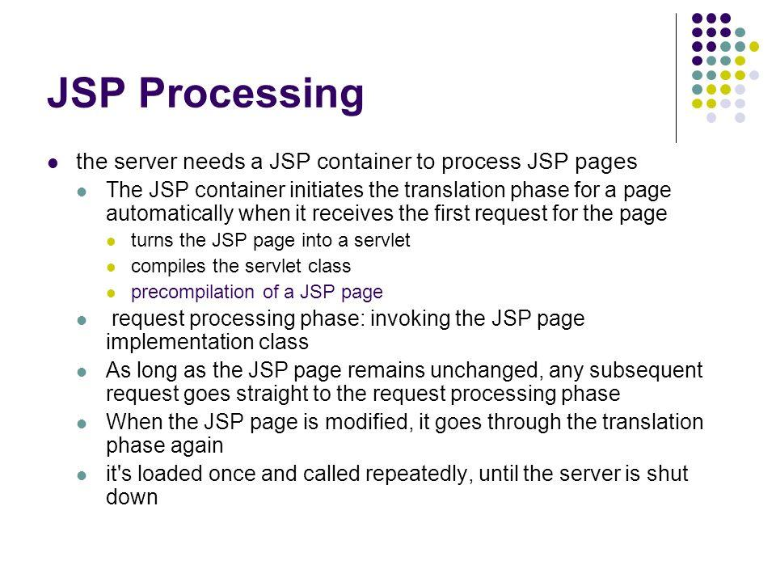

JSP are tag based approach to develop dynamic web application. JSP have all the features of Servlet because it is internally Servlet. It have following feature these are

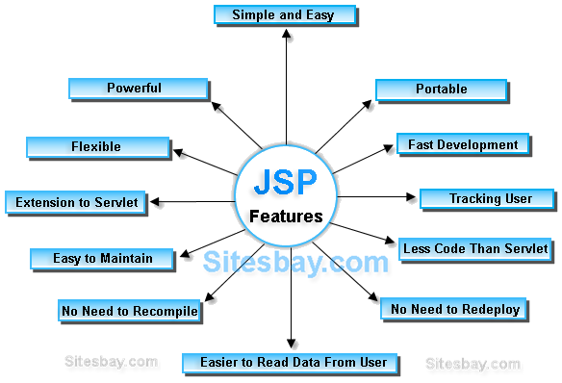

**Extension to Servlet:**JSP is Extension to Servlet, it have all the features of servlet and it have also implicit objects, predefined tags, expression language and Custom tags in JSP, that makes JSP easy to develop any application.

**Powerful:**These are internally Servlet, means consists byte code, so that all java features are applicable in case of jsp like robust, dynamic, secure, platform independent.

**Portable:**JSP tags will process and execute by the server side web container, So that these are browser independent and j2ee server independent.

**Flexible:**Allows to defined custom tags, the developer can fill conferrable to use any kind, framework based markup tags in JSP.

**Easy:**JSP is easy to learn, easy to understand and easy to develop. JSPs are more convenient to write than Servlets because they allow you to embed Java code directly into your HTML pages, in case of servlets you embed HTML inside of Java code.

**Less code than Servlet:**In JSP, we can use a lot of tags such as action tags, jstl, custom tags etc. that reduces the code.

**7.Discuss how to access a database from a JSP? Explain in detail**

**Ans:**

**8.Explain with suitable example, how to use Java Beans in JSP pages?**

**Ans:**

A JavaBean is a specially constructed Java class written in the Java and coded according to the JavaBeans API specifications.

Following are the unique characteristics that distinguish a JavaBean from other Java classes −

* It provides a default, no-argument constructor.
* It should be serializable and that which can implement the **Serializable** interface.
* It may have a number of properties which can be read or written.
* It may have a number of "**getter**" and "**setter**" methods for the properties.

## **JavaBeans Properties**

A JavaBean property is a named attribute that can be accessed by the user of the object. The attribute can be of any Java data type, including the classes that you define.

A JavaBean property may be **read, write, read only**, or **write only**. JavaBean properties are accessed through two methods in the JavaBean's implementation class

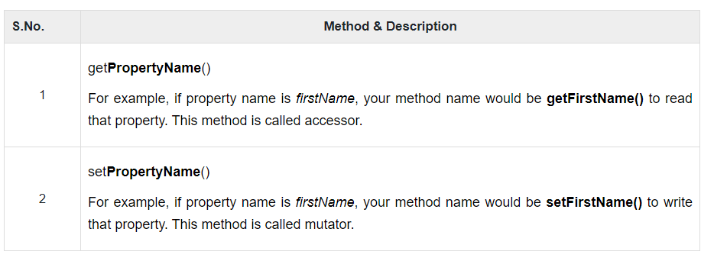

A read-only attribute will have only a **getPropertyName()** method, and a write-only attribute will have only a **setPropertyName()** method.

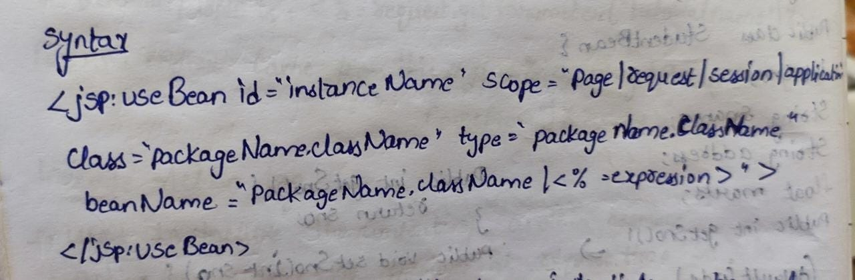

## **Simple example of JavaBean class**

1. //Employee.java
3. **package** mypack;
4. **public** **class** Employee **implements** java.io.Serializable{
5. **private** **int** id;
6. **private** String name;
7. **public** Employee(){}
8. **public** **void** setId(**int** id){**this**.id=id;}
9. **public** **int** getId(){**return** id;}
10. **public** **void** setName(String name){**this**.name=name;}
11. **public** String getName(){**return** name;}
12. }

To access the JavaBean class, we should use getter and setter methods.

1. **package** mypack;
2. **public** **class** Test{
3. **public** **static** **void** main(String args[]){
4. Employee e=**new** Employee();//object is created
5. e.setName("Arjun");//setting value to the object
6. System.out.println(e.getName());
7. }}

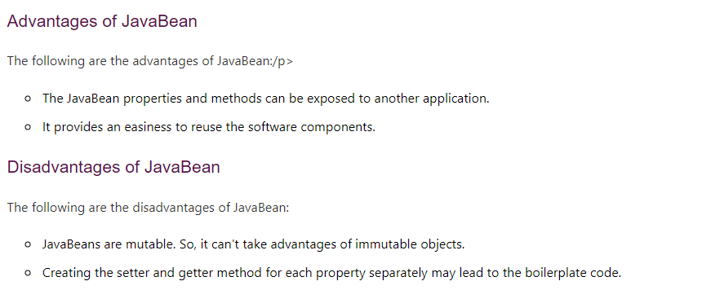

**Module-5**

1. **Explain various operators and data types available in java script.**

**Ans:**

# **JavaScript Operators**

JavaScript operators are symbols that are used to perform operations on operands. For example:

1. var sum=10+20;

Here, + is the arithmetic operator and = is the assignment operator.

There are following types of operators in JavaScript.

1. Arithmetic Operators
2. Comparison (Relational) Operators
3. Bitwise Operators
4. Logical Operators
5. Assignment Operators
6. Special Operators

## **JavaScript Arithmetic Operators**

Arithmetic operators are used to perform arithmetic operations on the operands. The following operators are known as JavaScript arithmetic operators.

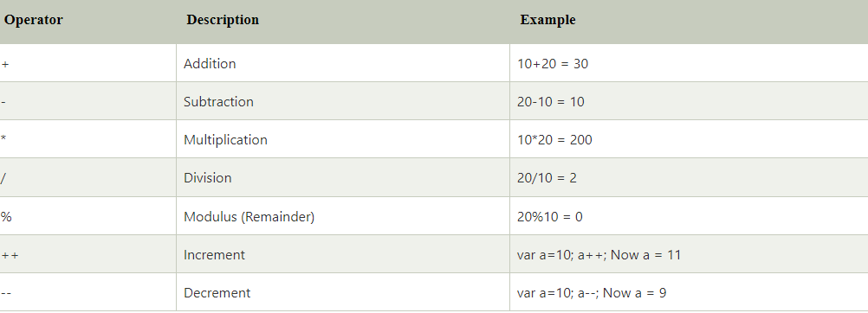

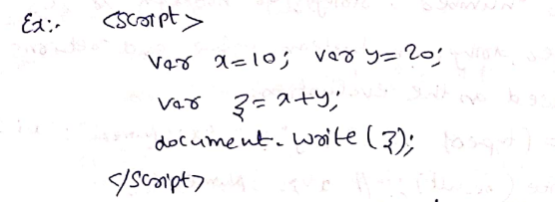

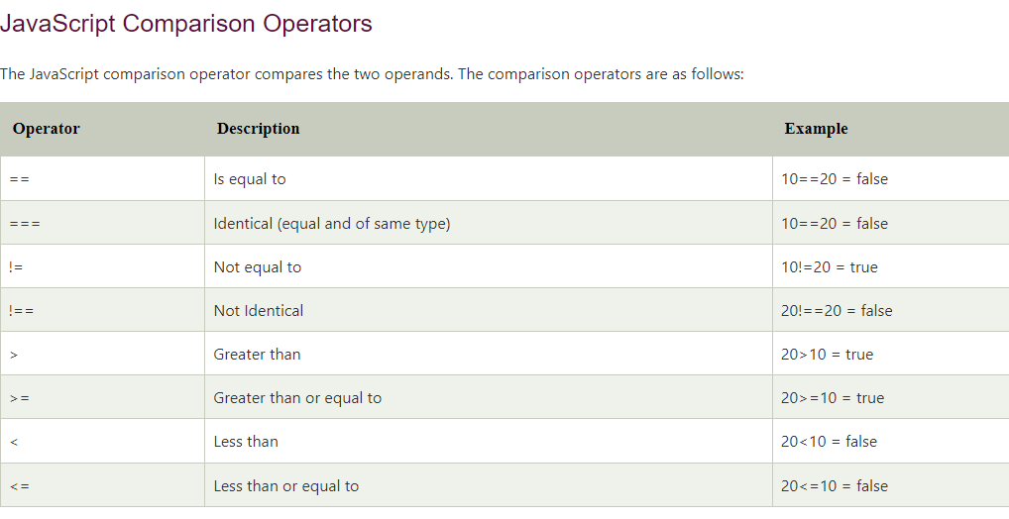

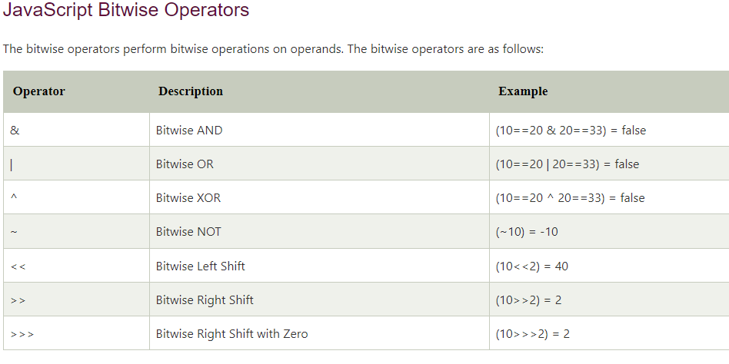

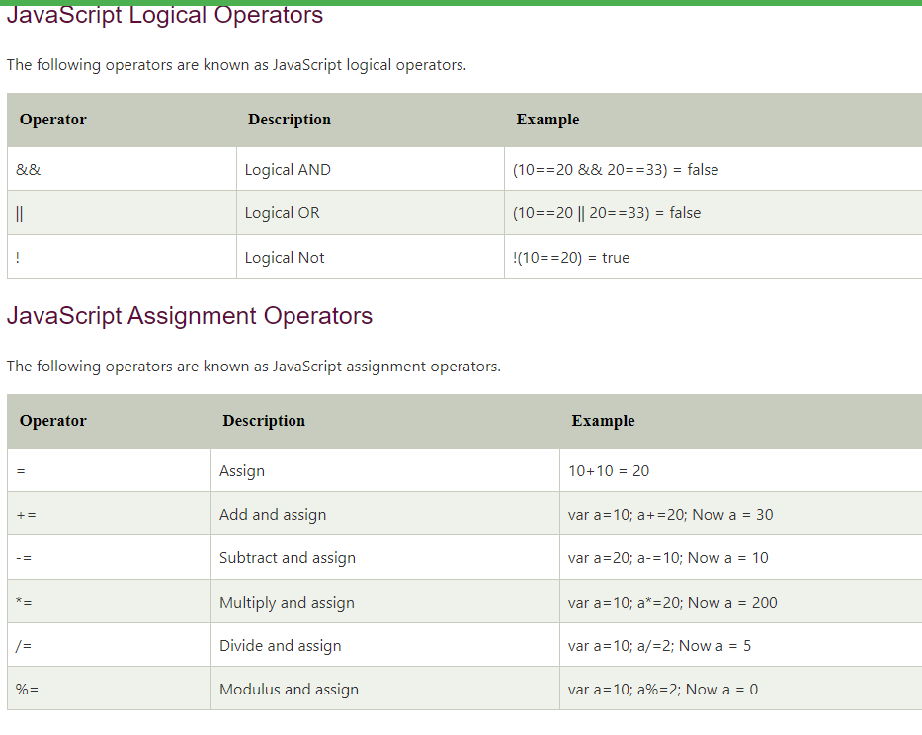

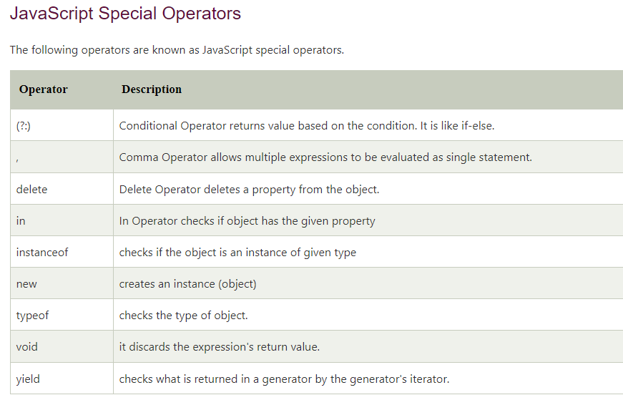

**Examples:**

### Arithmetic operators in JavaScript

### let x = 5;

### let y = 3;

### console.log('x + y = ', x + y); // 8

### console.log('x - y = ', x - y); // 2

### console.log('x * y = ', x * y); // 15

### console.log('x / y = ', x / y); // 1.6666666666666667

### console.log('x % y = ', x % y); // 2

### console.log('++x = ', ++x); // x is now 6

### console.log('x++ = ', x++); // prints 6 and then increased to 7

### console.log('x = ', x); // 7

### console.log('--x = ', --x); // x is now 6

### console.log('x-- = ', x--); // prints 6 and then decreased to 5

### console.log('x = ', x); // 5

### console.log('x ** y =', x ** y); //125

### Comparison operators in JavaScript

### console.log(2 == 2); // true

### console.log(2 == '2'); // true

### console.log(3 != 2); // true

### console.log('hello' != 'Hello'); // true

### console.log(2 === 2); // true

### console.log(2 === '2'); // false

### console.log(2 !== '2'); // true

### console.log(2 !== 2); // false

### Logical Operators in JavaScript

// logical AND

console.log(true && true); // true

console.log(true && false); // false

// logical OR

console.log(true || false); // true

// logical NOT

console.log(!true); // false

### String operators in JavaScript

// concatenation operator

console.log('hello' + 'world');

let a = 'JavaScript';

a += ' tutorial'; // a = a + ' tutorial';

console.log(a);

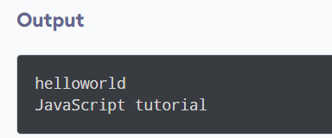

# **Javascript Data Types**

JavaScript provides different **data types** to hold different types of values. There are two types of data types in JavaScript.

1. Primitive data type
2. Non-primitive (reference) data type

JavaScript is a **dynamic type language**, means you don't need to specify type of the variable because it is dynamically used by JavaScript engine. You need to use **var** here to specify the data type. It can hold any type of values such as numbers, strings etc. For example:

1. var a=40;//holding number
2. var b="Rahul";//holding string

## **JavaScript primitive data types**

There are five types of primitive data types in JavaScript. They are as follows:

| **Data Type** | **Description** |
| --- | --- |
| String | represents sequence of characters e.g. "hello" |
| Number | represents numeric values e.g. 100 |
| Boolean | represents boolean value either false or true |
| Undefined | represents undefined value |
| Null | represents null i.e. no value at all |

## **JavaScript non-primitive data types**

The non-primitive data types are as follows:

| **Data Type** | **Description** |
| --- | --- |
| Object | represents instance through which we can access members |
| Array | represents group of similar values |
| RegExp | represents regular expression |

**2. Write a Java script programs to display array of student names**

**Ans:**

**JavaScript array** is an object that represents a collection of similar type of elements.

There are 3 ways to construct array in JavaScript

1. By array literal
2. By creating instance of Array directly (using new keyword)
3. By using an Array constructor (using new keyword)

**Example:**

<!DOCTYPE html>

<html>

<head> </head>

<body>

<center><h1>GeeksforGeeks</h1></center>

<ul id="myList"></ul>

<script>

let data = ["Ram", "Shyam", "Sita", "Gita"];

let list = document.getElementById("myList");

data.forEach((item) => {

let li = document.createElement("li");

li.innerText = item;

list.appendChild(li);

});

</script>

</body>

</html>

**Output:**

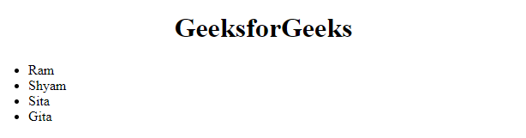

**3.Develop a program in JavaScript to convert temperature from Celsius to Fahrenheit and vice versa or Height from centimeters to inches and viceversa.**

**Ans:**

**Celsius to Fahrenheit**

<!DOCTYPE html>

<html>

<body>

<h2>JavaScript Celcius to Fahrenhet</h2>

<p>Insert a number into one of the input fields below:</p>

<p><input id="c" onkeyup="convert('C')"> degrees Celsius</p>

<p><input id="f" onkeyup="convert('F')"> degrees Fahrenheit</p>

<p>Note that the <b>Math.round()</b> method is used, so that the result will be returned as an integer.</p>

<script>

function convert(degree) {

var x;

if (degree == "C") {

x = document.getElementById("c").value * 9 / 5 + 32;

document.getElementById("f").value = Math.round(x);

} else {

x = (document.getElementById("f").value -32) * 5 / 9;

document.getElementById("c").value = Math.round(x);

}

}

</script>

</body>

</html>

**Output:**

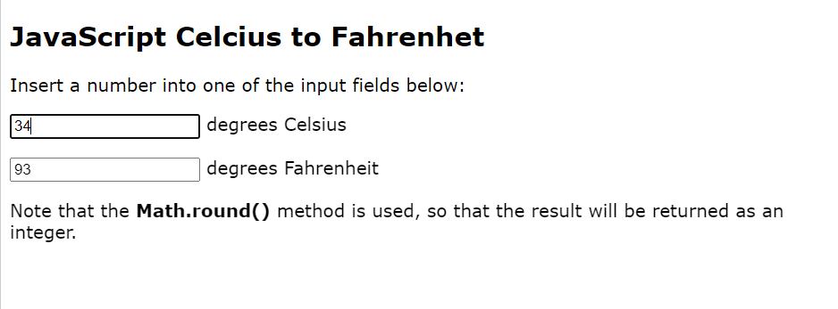

**Height from Centimeters to inches**

<html>

<title>Centimeter, Inches Conversion in JavaScript </title>

<script language="JavaScript">

function cmConverter(){

document.converter.inch.value = (document.converter.cm.value / 2.54).toFixed(2);

document.converter.feet.value = (document.converter.cm.value / 30.48).toFixed(2);

}

function inchConverter(){

document.converter.cm.value = (document.converter.inch.value * 2.54).toFixed(2);

document.converter.feet.value = (document.converter.inch.value / 12).toFixed(2);

}

function Clear() {

document.converter.cm.value ="";

document.converter.inch.value="";

document.converter.cm.focus();

}

</script>

<body>

<br>

<h3>Centimeter, Inches, and Feet Conversion in JavaScript</h3>

<form name="converter">

<label data-text="Centimeter">&nbsp;&nbsp;

cm<input type="text" name="cm" onChange="cmConverter()" required="">

</label>

<br />

<label data-text="Inches">&nbsp;&nbsp;

inch<input type="text" name="inch" onChange="inchConverter()" required="">

</label>

<br/>

<input type="button" value="Convert" title="Click here to convert." />

<input type="button" value="Clear"

title="Click here to clear the text box."

onclick="Clear()"/>

</form>

</body>

</html>

**Output:**

### Centimeter, Inches Conversion in JavaScript

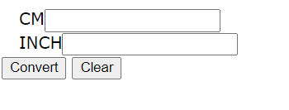

1. **Explain about object, methods and events in Java Scripts**

**Ans:**

# **JavaScript Objects**

A javaScript object is an entity having state and behavior (properties and method). For example: car, pen, bike, chair, glass, keyboard, monitor etc.

JavaScript is an object-based language. Everything is an object in JavaScript.

JavaScript is template based not class based. Here, we don't create class to get the object. But, we direct create objects.

## **Creating Objects in JavaScript**

There are 3 ways to create objects.

1. By object literal
2. By creating instance of Object directly (using new keyword)
3. By using an object constructor (using new keyword)

## **1) JavaScript Object by object literal**

The syntax of creating object using object literal is given below:

1. object={property1:value1,property2:value2.....propertyN:valueN}

Let’s see the simple example of creating object in JavaScript.

1. **<script>**
2. emp={id:102,name:"Shyam Kumar",salary:40000}
3. document.write(emp.id+" "+emp.name+" "+emp.salary);
4. **</script>**

#### **Output**

102 Shyam Kumar 40000

## **2) By creating instance of Object**

The syntax of creating object directly is given below:

1. var objectname=new Object();

Here, **new keyword** is used to create object.

Let’s see the example of creating object directly.

1. **<script>**
2. var emp=new Object();
3. emp.id=101;
4. emp.name="Ravi Malik";
5. emp.salary=50000;
6. document.write(emp.id+" "+emp.name+" "+emp.salary);
7. **</script>**

#### **Output**

101 Ravi 50000

## **3) By using an Object constructor**

Here, you need to create function with arguments. Each argument value can be assigned in the current object by using this keyword.

The **this keyword** refers to the current object.

The example of creating object by object constructor is given below.

1. **<script>**
2. function emp(id,name,salary){
3. this.id=id;
4. this.name=name;
5. this.salary=salary;
6. }
7. e=new emp(103,"Vimal Jaiswal",30000);
9. document.write(e.id+" "+e.name+" "+e.salary);
10. **</script>**

#### **Output**

103 Vimal Jaiswal 30000

## **Defining method in JavaScript Object**

We can define method in JavaScript object. But before defining method, we need to add property in the function with same name as method.

The example of defining method in object is given below.

1. **<script>**
2. function emp(id,name,salary){
3. this.id=id;
4. this.name=name;
5. this.salary=salary;
7. this.changeSalary=changeSalary;
8. function changeSalary(otherSalary){
9. this.salary=otherSalary;
10. }
11. }
12. e=new emp(103,"Sonoo Jaiswal",30000);
13. document.write(e.id+" "+e.name+" "+e.salary);
14. e.changeSalary(45000);
15. document.write("**<br>**"+e.id+" "+e.name+" "+e.salary);
16. **</script>**

#### **Output :**

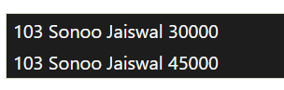

When JavaScript is used in HTML pages, JavaScript can **"react"** on these events JavaScript lets you execute code when events are detected.

HTML allows event handler attributes, **with JavaScript code**, to be added to HTML elements.

With single quotes:

<*element* *event*=**'*some JavaScript*'**>

With double quotes:

<*element* *event*=**"*some JavaScript*"**>

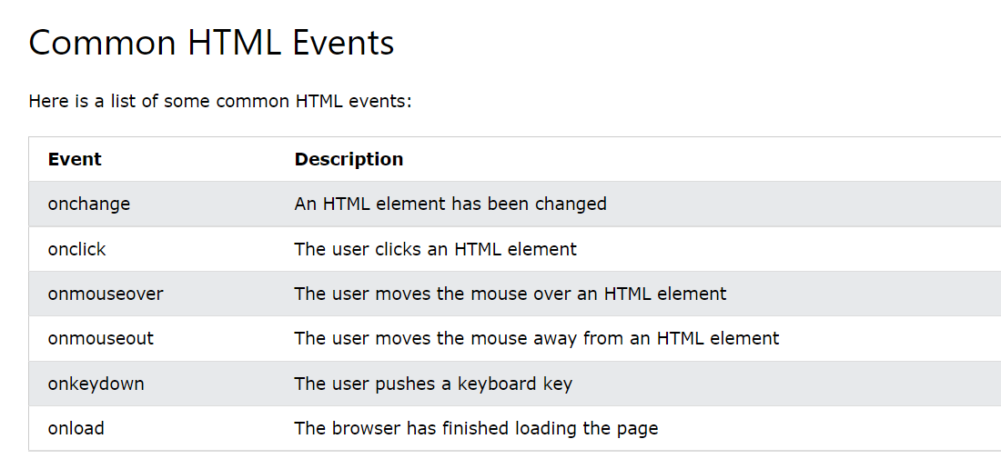

In the following example, an onclick attribute (with code), is added to a <button> element:

<!DOCTYPE html>

<html>

<body>

<button onclick="document.getElementById('demo').innerHTML=Date()">The time is?</button>

<p id="demo"></p>

</body>

</html>

**Output:**

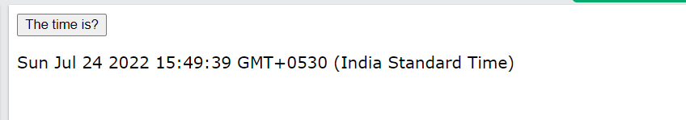

**5.Explain following objects of Java Script with an example: a) Math b) Date**

**Ans:**

**A)math**

The math object provides you properties and methods for mathematical constants and functions. Unlike other global objects, Math is not a constructor. All the properties and methods of Math are static and can be called by using Math as an object without creating it.

Thus, you refer to the constant pi as Math.PI and you call the sine function as Math.sin(x), where x is the method's argument.

**Syntax**

The syntax to call the properties and methods of Math are as follows

* var pi_val = Math.PI;
* var sine_val = Math.sin(30);

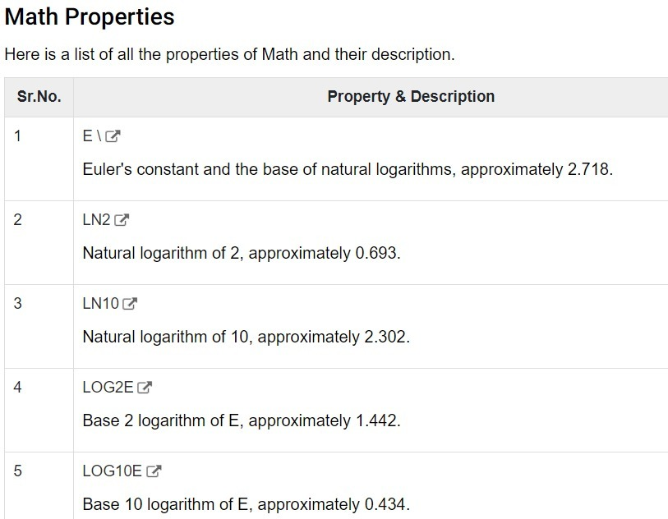

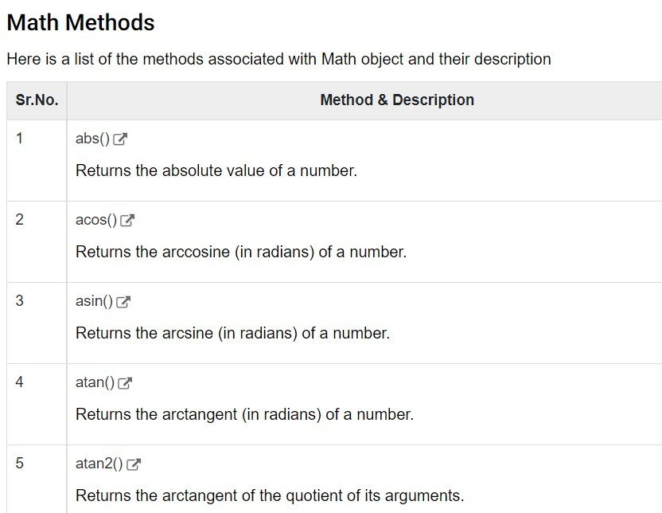

**Example:**

<!DOCTYPE html>

<html>

<body>

<h2>JavaScript Math.PI</h2>

<p>Math.PI returns the ratio of a circle's circumference to its diameter:</p>

<p id="demo"></p>

<script>

document.getElementById("demo").innerHTML = Math.PI;

</script>

</body>

</html>

**Output:**

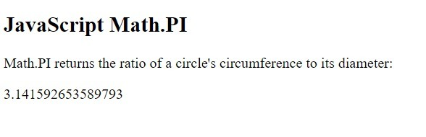

**b)Date**

The Date object is a datatype built into the JavaScript language. Date objects are created with the new Date( ) as shown below.

Once a Date object is created, a number of methods allow you to operate on it. Most methods simply allow you to get and set the year, month, day, hour, minute, second, and millisecond fields of the object, using either local time or UTC (universal, or GMT) time.

The ECMAScript standard requires the Date object to be able to represent any date and time, to millisecond precision, within 100 million days before or after 1/1/1970. This is a range of plus or minus 273,785 years, so JavaScript can represent date and time till the year 275755.

**Syntax**

You can use any of the following syntaxes to create a Date object using Date() constructor.

* new Date( )
* new Date(milliseconds)
* new Date(datestring)
* new Date(year,month,date[,hour,minute,second,millisecond ])

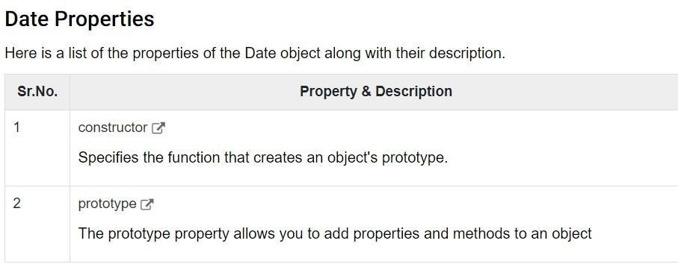

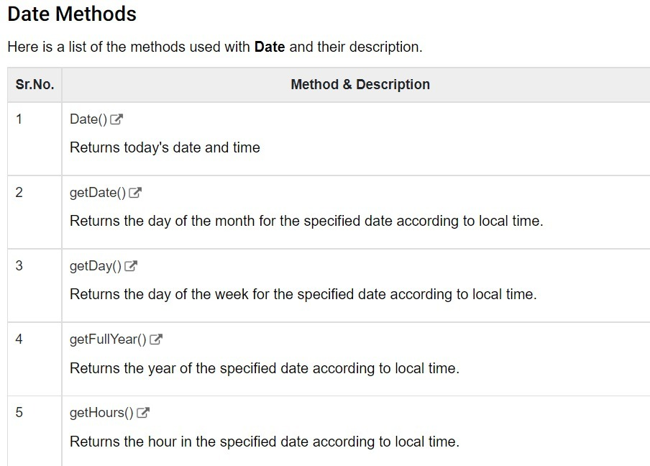

**Example:**

<!DOCTYPE html>

<html>

<body>

<h2>JavaScript new Date()</h2>

<p id="demo"></p>

<script>

const d = new Date();

document.getElementById("demo").innerHTML = d;

</script>

</body>

</html>

**Output:**

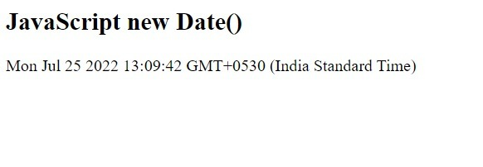

**6.Summarize how is Client side Java Script different from Server side Java Script?**

**Ans:** 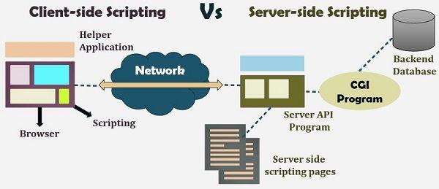

**Server-side scripting** is a technique of programming for producing the code which can run software on the server side, in simple words any scripting or programming that can run on the web server is known as server-side scripting. The operations like customization of a website, dynamic change in the website content, response generation to the user’s queries, accessing the database, and so on are performed at the server end.

The server-side scripting constructs a communication link between a server and a client (user). Earlier the server side scripting is implemented by the **CGI (Common Gateway Interface)** scripts. The CGI was devised to execute the scripts from programming languages such as C++ or Perl on the websites.

The server-side involves three parts: server, database, API’s and back-end web software developed by the server-side scripting language. When a browser sends a request to the server for a web page consisting of server-side scripting, the web server processes the script prior to serving the page to the browser. Here the processing of a script could include extracting information from a database, making simple calculations, or choosing the appropriate content that is to be displayed in the client end. The script is being processed and the output is sent to the browser. The web server abstracts the scripts from the end user until serving the content, which makes the data and source code more secure.

#### **Server-side scripting languages:**

After the advent of CGI, multiple programming languages were evolved such as PHP, Python, Ruby, ColdFusion, C#, Java, C++ and so on for server-side scripting among which some of them are described below:

**PHP:** It is the most prevalent server-side language used on the web which was designed to extract and manipulate information in the database. The language is used in association with SQL language for the Database. It is used in Facebook, WordPress and Wikipedia.

**Python:** The language is fast and contains shorter code. It is good for beginners as it concentrates on the readability and simplicity of the code. Python functions well in the object-oriented environment and used in famous sites like Youtube, Google, etc.

**Ruby:** It contains complex logic which packages the back-end with database utility which can also be provided by PHP and SQL.

Client-side Scripting

**Client-side scripting** is performed to generate a code that can run on the client end (browser) without needing the server side processing. Basically, these types of scripts are placed inside an HTML document. The client-side scripting can be used to examine the user’s form for the errors before submitting it and for changing the content according to the user input. As I mentioned before, the web requires three elements for its functioning which are, client, database and server.

The effective client-side scripting can significantly reduce the **server load**. It is designed to run as a scripting language utilizing a web browser as a host program. For example, when a user makes a request via browser for a web page to the server, it just sends the HTML and CSS as plain text, and the browser interprets and renders the web content in the client end.

#### **Client-side scripting languages:**

**HTML**: It is the fundamental building blocks of web programming which provides the frame to the website. It describes the arrangement of the content.

**CSS**: CSS provides the way to design the graphic elements which help in making the appearance of the web application more attractive.

**JavaScript**: It is also a client-side scripting language which essentially devised for the specific purpose, but currently there are various JavaScript frameworks used as server-side scripting technology.

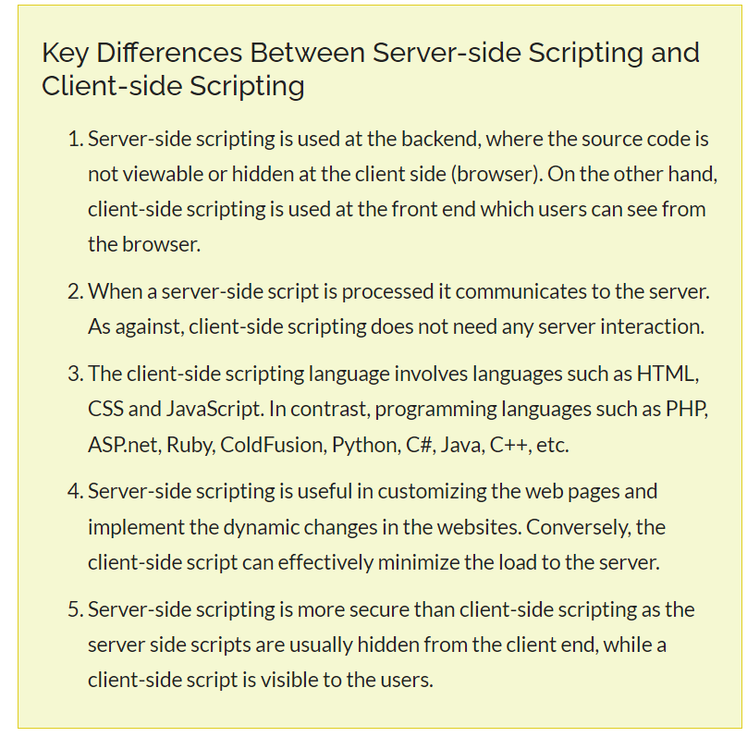

**7.Explain Document Object Model with suitable examples and code**

**Ans:**

# **Document Object Model**

The **document object** represents the whole html document.

When an html document is loaded in the browser, it becomes a document object. It is the **root element** that represents the html document. It has properties and methods. By the help of document objects, we can add dynamic content to our web page.

As mentioned earlier, it is the object of the window. So

1. window.document

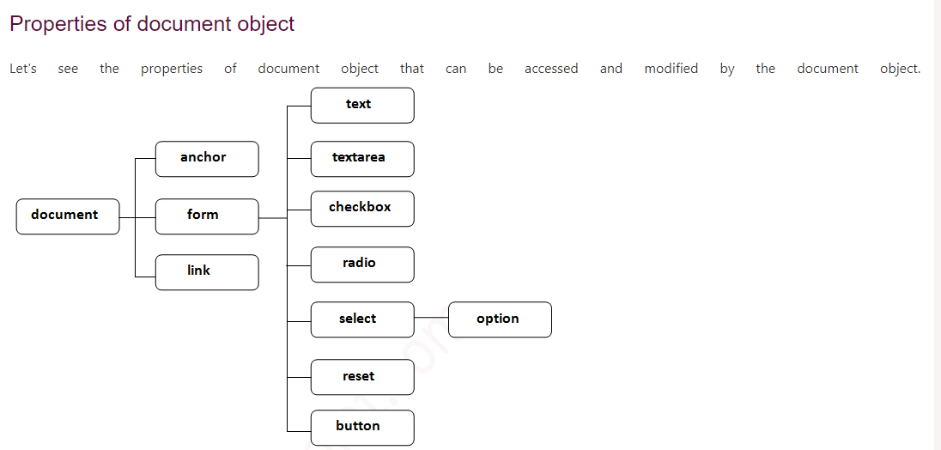

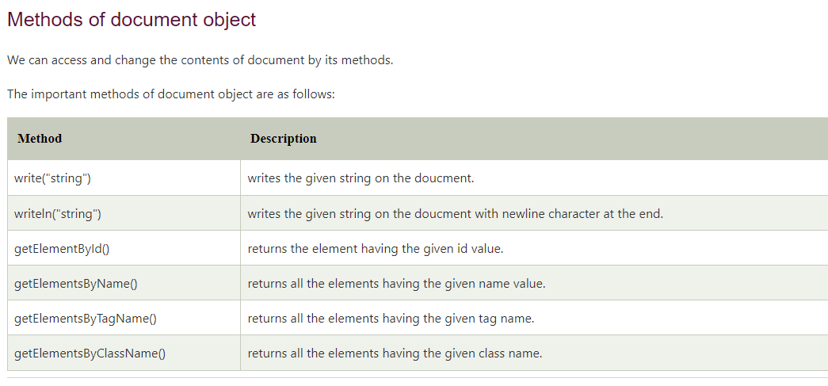

**Examples:**

1. **<script** type="text/javascript"**>**
2. function printvalue(){
3. var name=document.form1.name.value;
4. alert("Welcome: "+name);
5. }
6. **</script>**
8. **<form** name="form1"**>**
9. Enter Name:**<input** type="text" name="name"**/>**
10. **<input** type="button" onclick="printvalue()" value="print name"**/>**
11. **</form>**

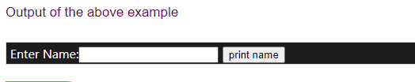

***document.getElementById()***

1. **<script** type="text/javascript"**>**
2. function getcube(){
3. var number=document.getElementById("number").value;
4. alert(number*number*number);
5. }
6. **</script>**
7. **<form>**
8. Enter No:**<input** type="text" id="number" name="number"**/><br/>**
9. **<input** type="button" value="cube" onclick="getcube()"**/>**
10. **</form>**

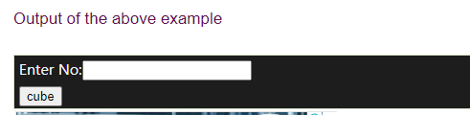

### *document.getElementsByName()*

1. **<script** type="text/javascript"**>**
2. function totalelements()
3. {
4. var allgenders=document.getElementsByName("gender");
5. alert("Total Genders:"+allgenders.length);
6. }
7. **</script>**
8. **<form>**
9. Male:**<input** type="radio" name="gender" value="male"**>**
10. Female:**<input** type="radio" name="gender" value="female"**>**
12. **<input** type="button" onclick="totalelements()" value="Total Genders"**>**
13. **</form>**

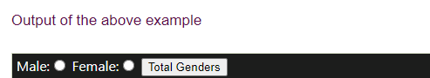

### *document.getElementsByTagName()*

1. **<script** type="text/javascript"**>**
2. function countpara(){
3. var totalpara=document.getElementsByTagName("p");
4. alert("total p tags are: "+totalpara.length);
6. }
7. **</script>**
8. **<p>**This is a pragraph**</p>**
9. **<p>**Here we are going to count total number of paragraphs by getElementByTagName() method.**</p>**
10. **<p>**Let's see the simple example**</p>**
11. **<button** onclick="countpara()"**>**count paragraph**</button>**

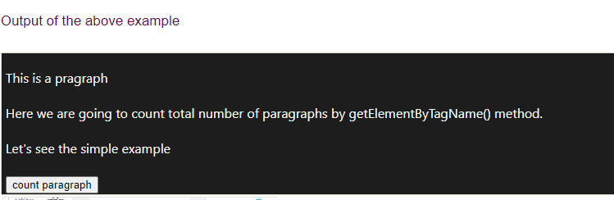

**8.Write short notes on Form Validation with an example**

**Ans:**

Form validation normally used to occur at the server, after the client had entered all the necessary data and then pressed the Submit button. If the data entered by a client was incorrect or was simply missing, the server would have to send all the data back to the client and request that the form be resubmitted with correct information. This was really a lengthy process which used to put a lot of burden on the server.

Through JavaScript, we can validate name, password, email, date, mobile numbers and more fields.

## **JavaScript Form Validation Example**

In this example, we are going to validate the name and password. The name can’t be empty and password can’t be less than 6 characters long.

Here, we are validating the form on form submit. The user will not be forwarded to the next page until given values are correct.

**<script>**

function validateform(){

var name=document.myform.name.value;

var password=document.myform.password.value;

if (name==null || name==""){

  alert("Name can't be blank");

  return false;

}else if(password.length**<6**){

  alert("Password must be at least 6 characters long.");

  return false;

  }

}

**</script>**

**<body>**

**<form** name="myform" method="post" action="abc.jsp" onsubmit="return validateform()"**>**

Name: **<input** type="text" name="name"**><br/>**

Password: **<input** type="password" name="password"**><br/>**

**<input** type="submit" value="register"**>**

**</form>**

**Output:**

